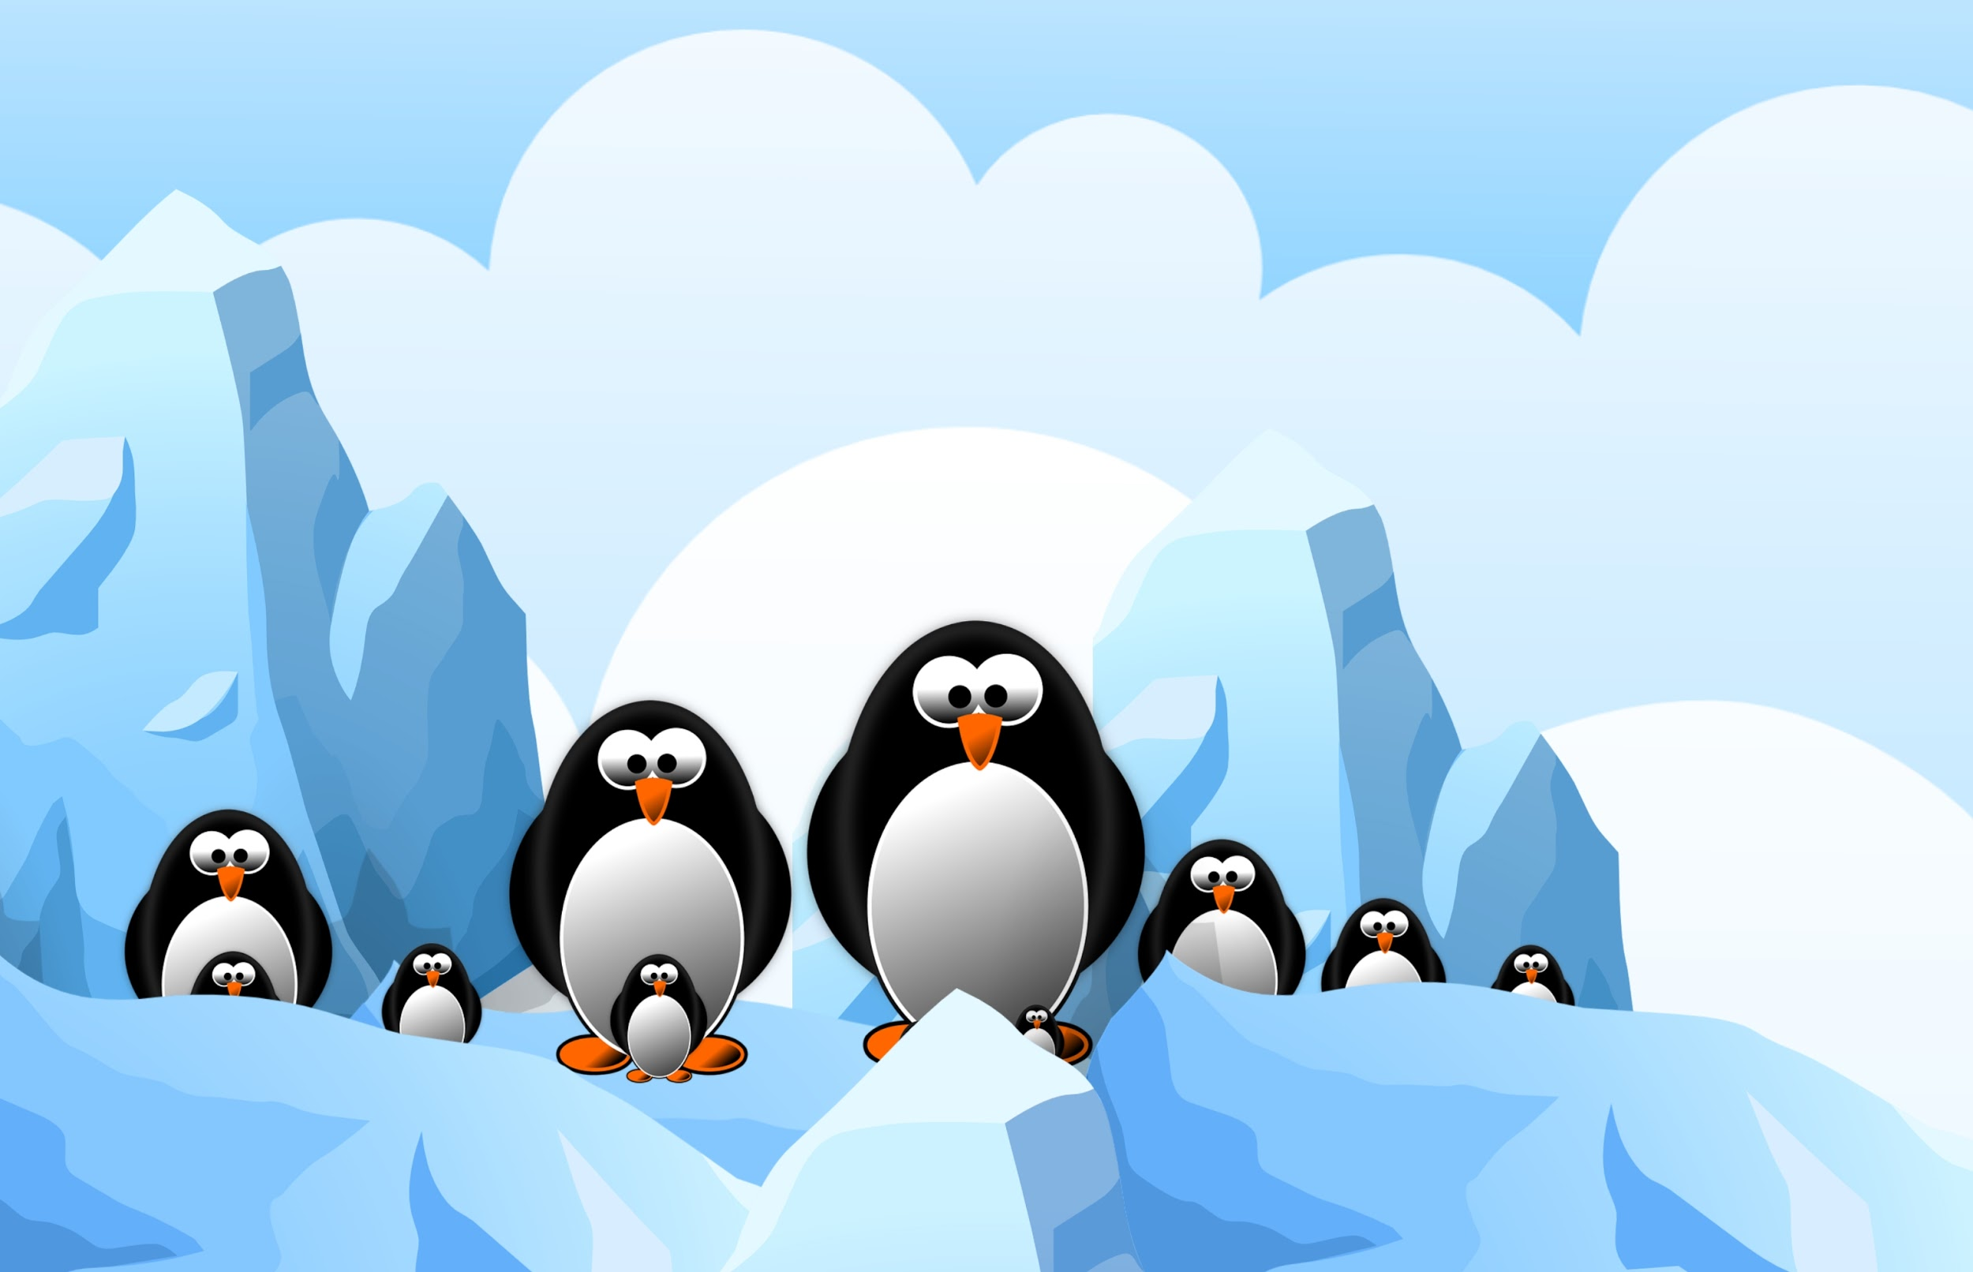
DAY 1:
Step 1: Before you begin designing and developing a way to create a safe haven for penguins, you need to review some basic information. Fill in the chart below to review some key concepts already discussed in class.

Term | Description | Example/ Picture
Temperature | The ________ kinetic energy of particles in a substance, does not depend on mass
Thermal Energy |  | A glacier has more thermal energy than a lit match because it is more massive
Heat
Convection |  | 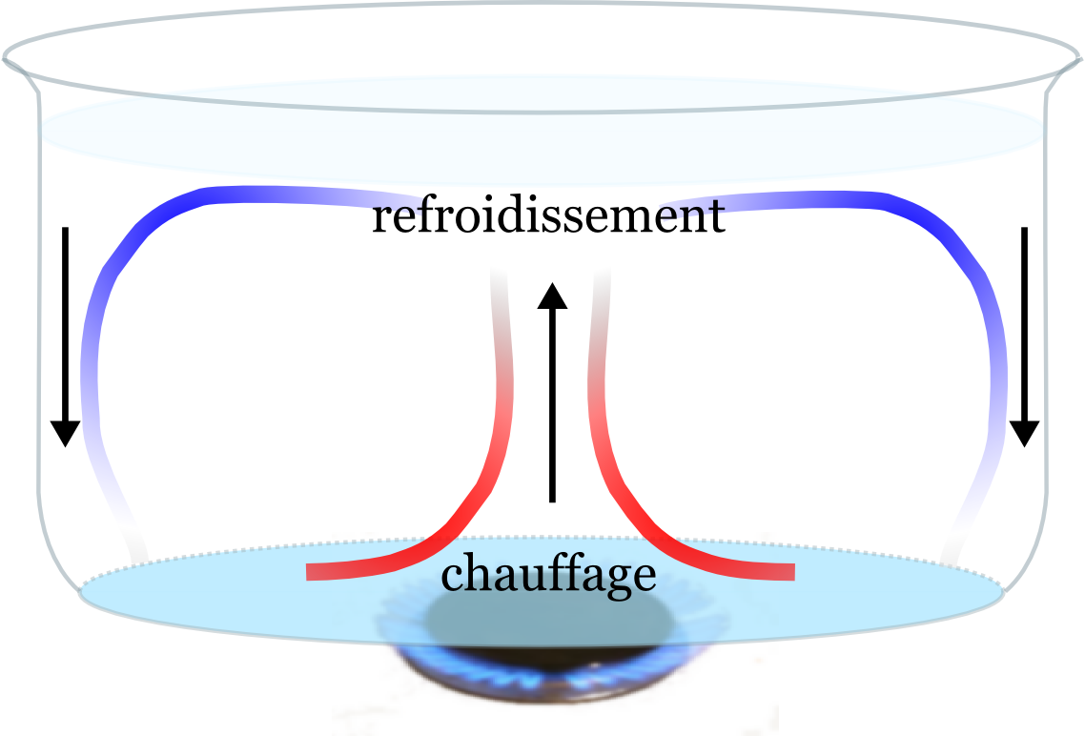
Conduction
Radiation | The transfer of thermal energy by ______________________________________
Insulator

Conductor |  | Usually made from metals like copper, gold, silver
Thermal Equilibrium

Specific heat | How easily a substance can increase or decrease temperature, depends on mass | Water has to gain more energy to raise its temperature than metals do because it has a higher rate of specific heat
Ambient temperature |  | EX: Typical room temperature is 20 degrees celsius.

Step 2: You are going on a field trip and you have to bring a “sack lunch” all materials have to be thrown away after lunch. You want to bring a cold can of soda, but aren’t sure how to keep it cold until lunch time. You decide to wrap the soda can in a material to keep it cold. Which material should you use a paper towel, aluminum foil, plastic wrap, wool sock, cotton sock? Explain which material you would choose. ______________________________________________________________________________________________________________________________________________________________________________________________________________________________________________________________________________________________________________________________________________________________________________

Step 3: Look at the information below, use the data to answer the questions

The effect of different insulators on soda temperatures:

Material | Temp. of soda after refrigeration (in F) | Temperature of soda after being out for 1 hour (in F)
Wool sock | 40 | 59.6
Paper Towel | 40 | 60.4
Aluminum foil | 40 | 61.3
Plastic wrap | 40 | 62.1
Cotton sock | 40 | 63.5
Nothing | 40 | 64.2

- What is happening to the temperature of each can of soda? ______________ What does that mean in terms of kinetic energy of the particles? ________________________________________________
- How much does the temperature increase for each material tested?
Wool sock _________ Paper towel______ Aluminum foil ________
Plastic wrap________ Cotton sock______ Nothing__________
- Make a claim: Which material works the best to keep the drink cool? ________________________________________________________
- What is a piece of evidence you could use to support your claim? __________________________________________________________________________________________________________________
- What do you think makes that material work the best? _________________________________________________________

Create a bar graph to represent each of the materials final temperature. Be sure to label each material and include degrees in F on the side of the graph.

Day 2: Testing materials
Mini lab #1-
You have 2 spoons on your desk, a metal spoon and a plastic spoon. Make a hypothesis in the space below.

- If metal is a ______________________ then it_____________ conduct thermal energy to the ice cube because _________________________________________________________
- Variables:
  - Dependent Variable:____________________________________
  - Independent variable:____________________________________
Complete the data table below:

Material | Time it takes to melt ice cube (in min)
Plastic spoon
Metal spoon

Analysis:
- Which material works the best help melt the ice? _________________
- Which type of heat transfer was this? __________________________
- Why do you think this material works better?

________________________________________________________

_________________________________________________________

________________________________________________________

Mini Lab #2
Next you will test various materials to see how well they transfer or block thermal energy.
Predict: Which materials in your bag do you think will heat up the most? ______________________________________________________________
Instructions:
- Take the starting temperature of each material before you begin, use the temperature gun to collect your data.
- Once you have done this, place the materials 2 at a time under the heat lamp for 1 minute
- After 1 minute use the temperature gun to record the new temperature

Data table:

Material | Starting temp. | Temp. after 1 min.
White Foam
Black foam
Mylar
Aluminum
Black paper
White paper
White foam w/ mylar on top
Black foram w. Mylar top
Two sheets of mylar
Two sheets of Aluminum
Paper cup
Black paper on top of bubble wrap
White paper on top of bubble wrap

Now that you have tested different materials, think about how you could combine these materials to save a penguin ice cube from melting.

Constraints: You will be given a TEAM “debit” card with $100 on it. You cannot go over your limit. You must purchase materials from the Igloo Depot and combine them to create a device to MINIMIZE thermal energy transfer so you can save your penguin. Choose your items carefully, you may only make revisions and returns once!
Igloo Depot Items for Sale
Foam sheet $40 Felt fabric $40 Bubble wrap $40 Mylar sheet $40
1 Dixie Cup $10 5 Cotton balls $10 4 Wood sticks $10
Aluminum foil $5 Wax paper sheet $5 Construction paper $5 Plastic Wrap $5

Based on the data you just collected; which materials do you plan to purchase? Remember the total to build your device cannot go over $100
________________________________________________________________________________________________________________________________________________________________________________________________________________________________________________________Total Cost = $ _____________________
Explain WHY you want to build your device with those materials. ____________________________________________________________________________________________________________________________________________________________________________________________________________________________________________________________________________________________________________________________________________________________________________________

In the space below draw AND label a prototype that will be your penguin igloo.
**** You must have a small area to open and close to record temperature****

Save the Penguins- Day 3
Today you need to:
- Purchase your materials
- Build your device
- Test your device twice if time allows- If you need to make exchange materials or revise your design, now is the chance to do so.

To test your device:
- Build your device according to your plan
- Set device under the heat lamp
- Record the temperature every 2 minutes using the temp. Gun
- If time allows for a second trial- repeat steps 1-3 but add an ice cube inside of your igloo. Record the mass before your start your trial and again when your trial is done.

Time in Min. | Temp. (Trial 1) | Temp. (trial 2) | Mass of ice cube in g. (trial 2)
0
2
4
6
8
10
12
14
16
18
20

Post trial questions:
- Did your igloo work to block out the thermal energy from the lamp? ______________
- What way is heat transferring to the igloo? __________________
- Do you think you need to revise your design? ________ If so, what will you change?___________________________________________________ Why would you make that change? _________________________________________________________
- What is the overall change in temperature? _____________
- Do you think that will work well enough to keep your penguin safe? _________________________________________________________

Save the Penguin! Day 4
Today is the day to put your device to the test. Your device will be put inside of a heat chamber with 4 heat lamps for 20 minutes! The higher percentage (based on mass) of your penguin that remains, the higher your project score will be!

While your device is being tested you must complete the conclusion portion of this lab.
- What was the mass of your penguin before going into the heat chamber? ______________; what was the mass after? ______________ What percentage of it survived? _____________________________
- If the mass of your icecube was tripled, how would that impact the percentage of your “penguin’ that survived? Explain your reasoning using key vocab. ________________________________________________________________________________________________________________
- Create a graph based on yesterday’s trial 1 to show how the temperature of your device changed over time. (Line graph)

- How do you think the results would be different if you used conductors instead of insulators? ___________________________________________________________________________________________________________________________________________________________________________
- What were some constraints that limited you in the design of your igloo? _______________________________________________________ Do engineers in the real world face the same problems? Explain. __________________________________________________________________________________________________________________

- What would you do differently the next time? Why? __________________________________________________________________________________________________________________
- Was your device successful? Why? Why not? ____________________________________________________________________________________________________________________________________________________________________________________________________________________________________
- Reflect: How has completing this challenge helped you understand how thermal energy transfers and how insulators work? ____________________________________________________________________________________________________________________________________________________________________________________________________________________________________
- Reflect: Are there problems in the world that could be solved by using scientific designs like the one you created? Explain. ____________________________________________________________________________________________________________________________________________________________________________________________________________________________________
- What are some other ways you could use your knowledge of insulators, conductors and thermal energy transfers? Identify at least 3.

cks $10

nn
Aluminum foil $5
Wax paper sheet $5
Construction paper $5
Plastic Wrap

